We Are All Created Equal: Preventing Violence Against Women and Girls in Fiji’s Faith Settings

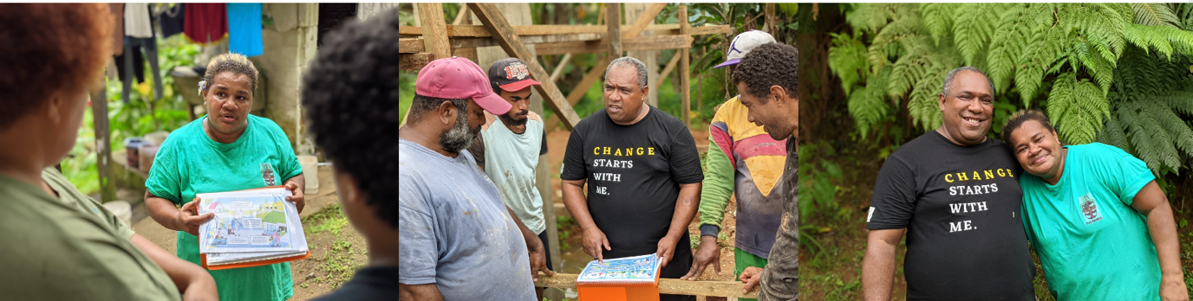

This paper is for policy makers, practitioners and faith-based organisations working to prevent VAWG in faith settings in Fiji, the Pacific, and beyond. It describes the journey of House of Sarah, a faith-based civil society organisation in Suva, Fiji, working to prevent VAWG, and documents evidence and lessons so that others may learn from and be inspired by their experience to adapt faith-based prevention programming to their own contexts.

Note about this document: This document has been formatted to meet Web Accessibility Guidelines AA standards, with improved accessibility for people with differing abilities.

Table of contents
We Are All Created Equal: Preventing Violence Against Women and Girls in Fiji’s Faith Settings 1
Introduction 3
Introduction to House of Sarah 6
House of Sarah: Faith communities taking a stand against violence against women and girls (Timeline) 7
Why the name ‘House of Sarah’? 8
Churches and faith settings are fundamental to preventing VAWG 9
Embarking on House of Sarah’s journey to address VAWG 9
Response and support services 9
Awareness raising on violence against women and girls 11
Internal policies for addressing violence against women and girls 12
Primary prevention for violence against women and girls 13
Preventing Violence against women in Fiji’s Faith Settings (PVAWFFS Project) 13
Progress to date: The evidence 16
Challenges and successes of PVAWFFS 16
Principles and values for positive change in faith communities 18
Looking ahead 21
Creating a future that is safe, equal, and free from violence 21
Acknowledgements 22
End notes 24

Introduction
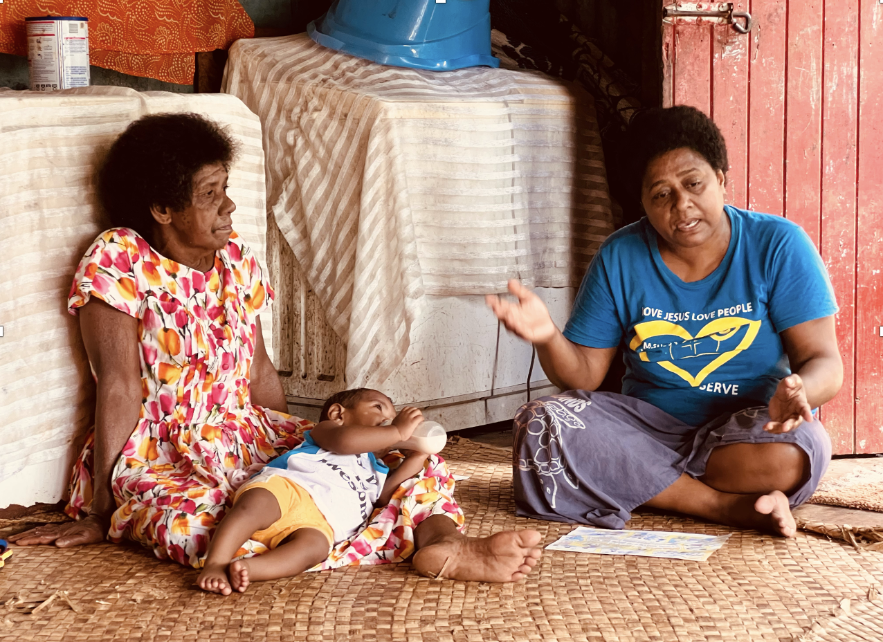

Violence against women and girls (VAWG) takes many forms and, while there are many drivers, its root cause is gender inequality. VAWG is a serious, global human rights and public health issue that must be prevented.

While it is vital to provide services that support survivors of VAWG, meaningful progress in addressing VAWG must address its root causes at every level of society –individual, interpersonal, community and societal.

A critical area of social life that cuts across every level of society is religious faith. Faith plays an important role in people’s lives, relationships, and communities, and is an influential setting that has the power to address VAWG. There is emerging global evidence on what works to prevent VAWG in faith settings with promising interventions and practices. Globally, around one in three women experience VAWG in their lifetime. In the Pacific, rates are even higher. In Fiji almost two in three women (64%) have experienced physical and/or sexual violence by an intimate partner in their lifetime. Evidence collected over the past two decades shows communities and societies can stop violence before it starts; prevention of violence is possible within our lifetime. Faith, faith leaders, and faith communities play a vital role in many people’s lives. They provide fundamental social and moral guidance for communities and are also where important social networks and norms form. Gender inequality and norms that allow VAWG to occur manifest across all aspects of society and daily life, including within places of worship. Faith settings have the potential to enable a society that normalises VAWG or, faith settings can harness their power to ensure women and girls live their utmost potential, without fear of violence within the faith community and in society more broadly. The evidence is growing on what works to prevent VAWG, especially strategies that strengthen relationships, empower women, and transform harmful attitudes, beliefs, and norms into those that are more gender equal. Implementation of these strategies in faith settings is crucial if we are to see lasting social norms change of VAWG in Fiji, in the Pacific and around the world.

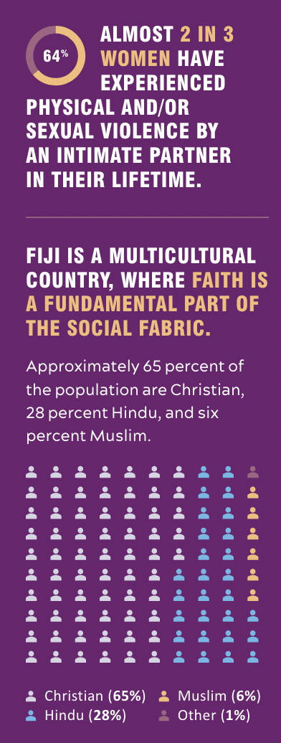

Introduction to House of Sarah
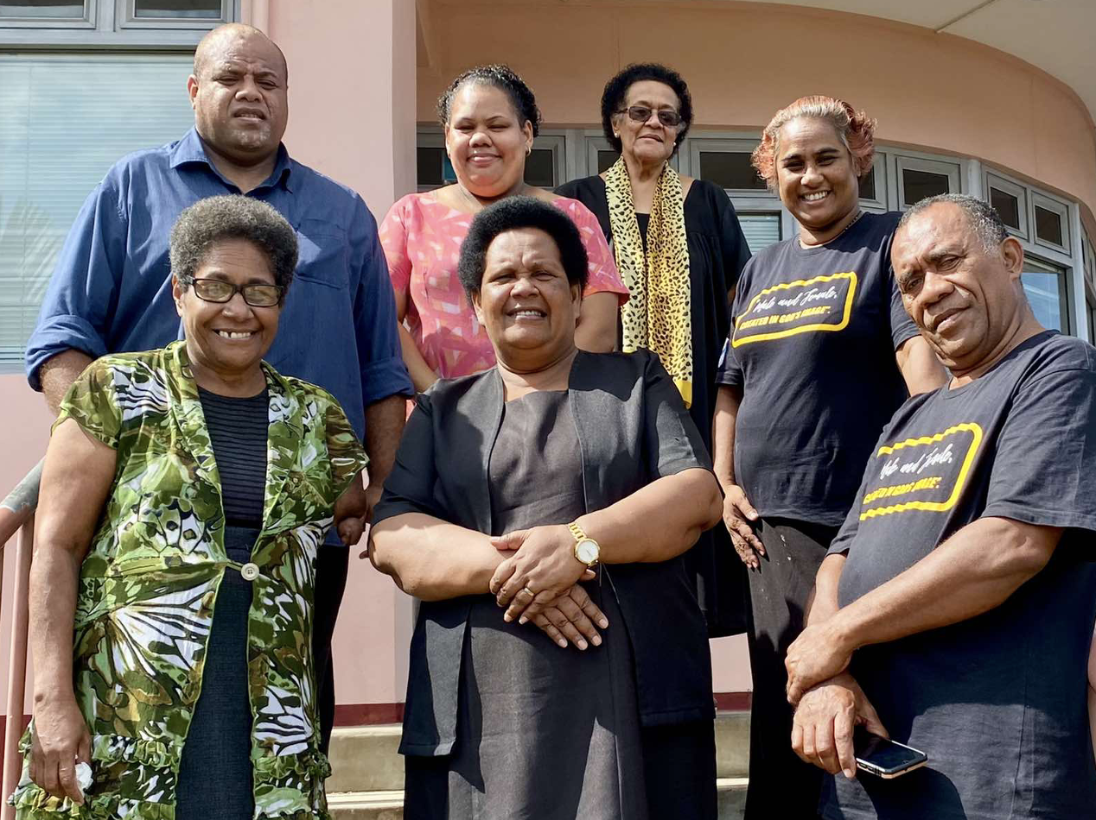
“In those years, I was aware of what was happening... Within the church, women were also facing the same reality that other women in Fiji were facing – violence in their homes from their partners. But in the church, it was not talked about openly.”– Reverend Sereima Lomaloma

Since 2009, House of Sarah, a ministry closely aligned with the Anglican Diocese of Polynesia, has been at the heart of responding to and preventing violence against women and girls through faith in Fiji and across the Pacific region. Its founder, Reverend Sereima Lomaloma, recognised early the need for faith-centered, tailored, well-resourced, comprehensive, and holistic services in the community that raise awareness on VAWG, support women and girls experiencing it, and stop violence before it starts.

Ever since then, House of Sarah has gone from strength to strength and recognises everyone has a role to play in preventing VAWG.

At the time of writing, House of Sarah:

- Employs five full-time staff (3 women and 2 men)
- Has five board members (5 women)
- Welcomes 26 volunteer community activists (17 women and 9 men) in a variety of roles, and 26 Sarah Carers in 13 communities (See page 9-10)
- Supports countless community members through various response, advocacy, and prevention initiatives. Over 100 community members (mostly women) have accessed support from the Sarah Carers and Dauveivukei Ecumenical team (See page 9-10)
- Partners with UN Women through the Pacific Partnership to Prevent Violence Against Women and Girls (Pacific Partnership) to progress gender equality goals. Other present and past partners include, Women’s Fund Fiji, Australian Department of Foreign Affairs and Trade (DFAT), Anglican Missions, Federal Republic of Germany in Wellington, Anglican Diocese of Polynesia.

House of Sarah: Faith communities taking a stand against violence against women and girls (Timeline)
2005 – 2007 Scoping begins for establishing House of Sarah, a safe, faith-based place where women and girls could seek help from violence

2009 House of Sarah officially opens its doors

2012 House of Sarah was registered under the Charitable Trust Act (Cap 67) in Fiji

2013 Establishment of Break the Silence Sunday campaigns as a part of the global 16 Days of Activism Against Gender-Based Violence

2016 Reverend Sereima attends a SASA! workshop in Papua New Guinea and the seeds for VAWG prevention at House of Sarah are sewn
2016 Establishment of Sarah Carers

2017 House of Sarah staff attends capacity development for SASA! Faith in Uganda

2018 Launch of the Preventing Violence Against Women in Fiji’s Faith Settings programme, which implements the SASA! Faith methodology adapted to Fiji’s context

2019 Sarah Carers Commissioned

2022 Culmination of the first phase of PVAWFFS and SASA! Faith

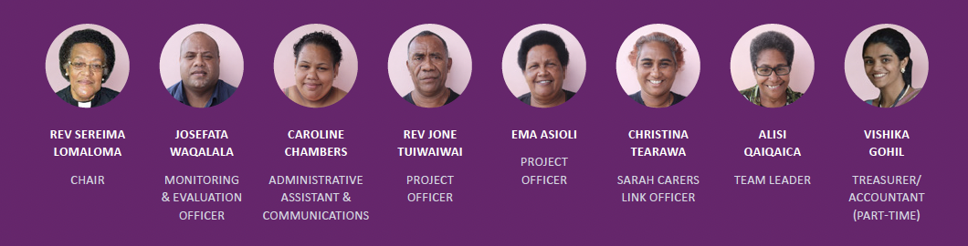

Why the name ‘House of Sarah’?
Sarah was the wife of Abraham in the Bible. Originally called Sarai, she did not have children and was full of doubt about her acceptance, until God blessed her, promising she would have a child. She became a woman of promise and a mother of nations. Her name change signifies a woman whose life was totally transformed by the grace of God. The vision of the House of Sarah is that those who are vulnerable and come to its doors will find a safe-haven and their life will be transformed. House of Sarah is a ministry that puts into practice God’s calling to stand alongside those in need of care, love, and compassion. Their mission is to provide: a listening ear, a warm heart to those in need, and a welcoming hand.

Churches and faith settings are fundamental to preventing VAWG
“A proactive stance by faith-based organisations in Pacific Island settings is critical for addressing VAWG, because of the pervasive influence that religions have on the values, attitudes, norms and behaviour of women and men.” – Reverend Sereima Lomaloma

With more than 80 percent of people around the world affiliated with a religion, faith settings play an important role in people’s lives. Faith-based leaders and organisations are uniquely placed to respond to VAWG, due to their community standing and reach and their capacity to mobilise resources beyond those available to the state or international aid organisations.

Christianity is the dominant religion in the Pacific and churches wield a lot of influence across all areas of life. Religious norms and customary interpretations of religious texts can perpetuate and justify VAWG and reinforce harmful gender norms, which can be used to marginalise and harm women. Due to their influence, it is required that churches and faith leaders play a leading role in transforming harmful gender norms and motivate respectful, non-violent and equal treatment of women.

Embarking on House of Sarah’s journey to address VAWG
Evidence shows the most effective way to address VAWG is to adopt a multi-level, multi-pronged approach. House of Sarah addresses VAWG in four key areas: response services, awareness raising and advocacy, policy implementation and primary prevention.

Response and support services
At the heart of House of Sarah’s response efforts are the Sarah Carers and the Dauveivukei Ecumenical team, a group of Christian women who are community-based volunteers, trained to provide personal support and counselling for women experiencing violence. Coming from 13 Anglican faith communities, the number of Sarah Carers has grown from 12 in 2019 to 26 in 2022 and the 5 Dauveivukei from House of Sarah, have joined 12 others within the wider Dauveivukei Ecumenical Network, all now working as trained, Christian counsellors. The community-based volunteers bridge communities and other formal services, such as health, justice, and counselling services. They are fully trained in survivor-centered principles and human rights-based approaches and provide a vital link to national gender-based violence (GBV) referral systems, as outlined in the Fiji National Service Delivery Protocol for Responding to Cases of Gender-Based Violence.

“As a Sarah Carer, I am proud to say that the training has given me a deeper commitment to end violence in all its forms. Learning the Bible says that women and men are created equal is very important.” – Estia Vuki, Sarah Carer

Successes and challenges to response and support services
The Sarah Carers and Dauveivukei have faced some challenges implementing support services. In Fiji, and similar to countries around the world, violence within the family is considered a private matter; many survivors do not report violence or seek formal support services due to shame, stigma and fear of the consequences of seeking help. Communities are small, people know each other well, including the Sarah Carers, so some women hesitate to reach out to them fearing their confidentiality may be breached. However, over time the Sarah Carers and Dauveivukei have developed trust within the community. The voluntary nature of the work also challenges the sustainability of the Sarah Carers, as they make time in their own schedules and use their own resources, such as mobile phones, to support women and link them to VAWG services in Fiji. Despite these challenges, the demand for the Sarah Carers and Dauveivukei support is clear. Between 2019 and 2021, approximately 100 people in the community (mostly women) reached out to the Sarah Carers for support. One key to their success is the trust Sarah Carers and Dauveivukei have been able to build, as well as endorsement by religious leaders. One Sarah Carer said: “A pastor introduced me as a Sarah Carer providing services in our community. The news quickly spread across the community. The next day, everyone came to my doorstep. For the first time, women were empowered to take the first step to seek help.”

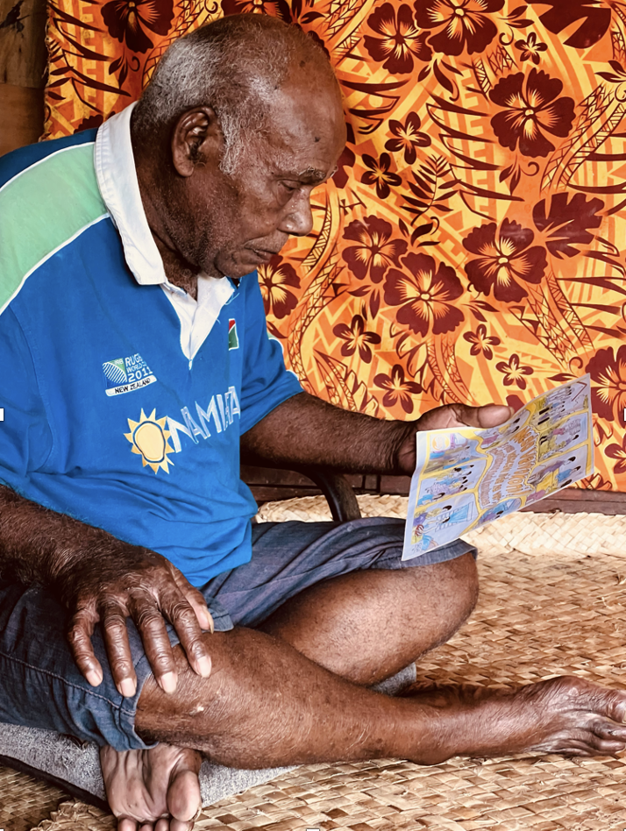

Awareness raising on violence against women and girls
Raising awareness on VAWG is an important part of its prevention as increased awareness can help change attitudes and behaviours that perpetuate violence. Across Fiji and the region, House of Sarah is involved in raising awareness around VAWG, human rights, gender equality and their relationship with Biblical texts.

Break the Silence Sunday
House of Sarah pioneered the development of the Break the Silence Sunday (BTS) campaign with Christian Talanoa Network (CTN) in 2013. Part of the 16 Days of Activism Against Gender-Based Violence Campaign, BTS calls on Christian leaders to give sermons on VAWG and its prevention and House of Sarah produces the liturgical resources. The campaign has been adopted by multiple denominations in Fiji and it is also observed by the Diocese of Polynesian churches in American Samoa, Samoa, and Tonga. In 2020, House of Sarah began to partner with the Pacific Conference of Churches, a regional faith institution in the Pacific, to implement BTS across the region.

One Voice Campaign
In 2016, the Fiji Council of Churches, with support from the House of Sarah and UN
Women Fiji Multi-Country Office (MCO) launched the national, multimedia, One
Voice Campaign, engaging Christian, faith leaders to speak out against VAWG. In
2018, Hindu, Muslim and Sikh faith leaders also joined the campaign. Initially it was
challenging to recruit multi-faith leaders, however House of Sarah mobilised the Women of Faith group (a women’s inter- faith group founded by House of Sarah in 2018) who convinced their leaders to support the campaign. With Pacific Conference of Churches, House of Sarah produced One Voice Campaign videos for television in Tonga and Samoa in 2020 and 2021, respectively.
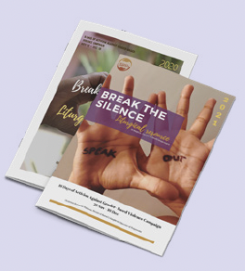

Internal policies for addressing violence against women and girls
Policies for preventing and responding to VAWG at an institutional level are critical. It is important that any organisation working to prevent VAWG not only works on community-facing projects, but work to address and strengthen their internal capacities and commitments to creating safe, inclusive spaces for all that are free of violence. Robust policies provide clear guidelines on staff/clergy/volunteer codes of conduct, zero tolerance of violence within the church or faith organisations and ensuring safety of all; these policies help to hold organisations, their clergy, staff, and volunteers accountable.

To have these policies approved and implemented requires advocacy, political will, and trust-building with and within the Church and faith organisations. House of Sarah has led policy development both within the Anglican Church and with other faith organisations. In 2013, House of Sarah and members of the Diocesan Synod advocated at the highest levels of the Anglican Diocese of Polynesia, the Synod of the Anglican Church, for the adoption of the Zero Tolerance to Violence resolution in 2013 stating that “within the Diocese of Polynesia there be Zero Tolerance of Violence within our homes, schools, settlements and the church”. This is significant because at the time 90 percent of the membership was men. This helped formalise the Anglican Church’s commitment to preventing VAWG and increased the legitimacy of House of Sarah’s work to address VAWG in the wider community.

Primary prevention for violence against women and girls
The best way to address VAWG is to stop it before it starts. Before embarking on primary prevention, it was vital to increase community awareness of VAWG and available support services. After House of Sarah established and strengthened Sarah Carers and the policies of the Anglican Church, they moved into primary prevention.

Preventing Violence against women in Fiji’s Faith Settings (PVAWFFS Project)
In 2018, House of Sarah partnered with UN Women and Women’s Fund Fiji (2018 – 2020) and received technical support from Raising Voices, to pilot the “Preventing Violence against Women in Fiji’s Faith Settings” (PVAWFFS) project in three Christian communities in Fiji: St Mark’s in Newtown; St Michael and All Angels in Matata; and St John the Baptist in Wailoku.

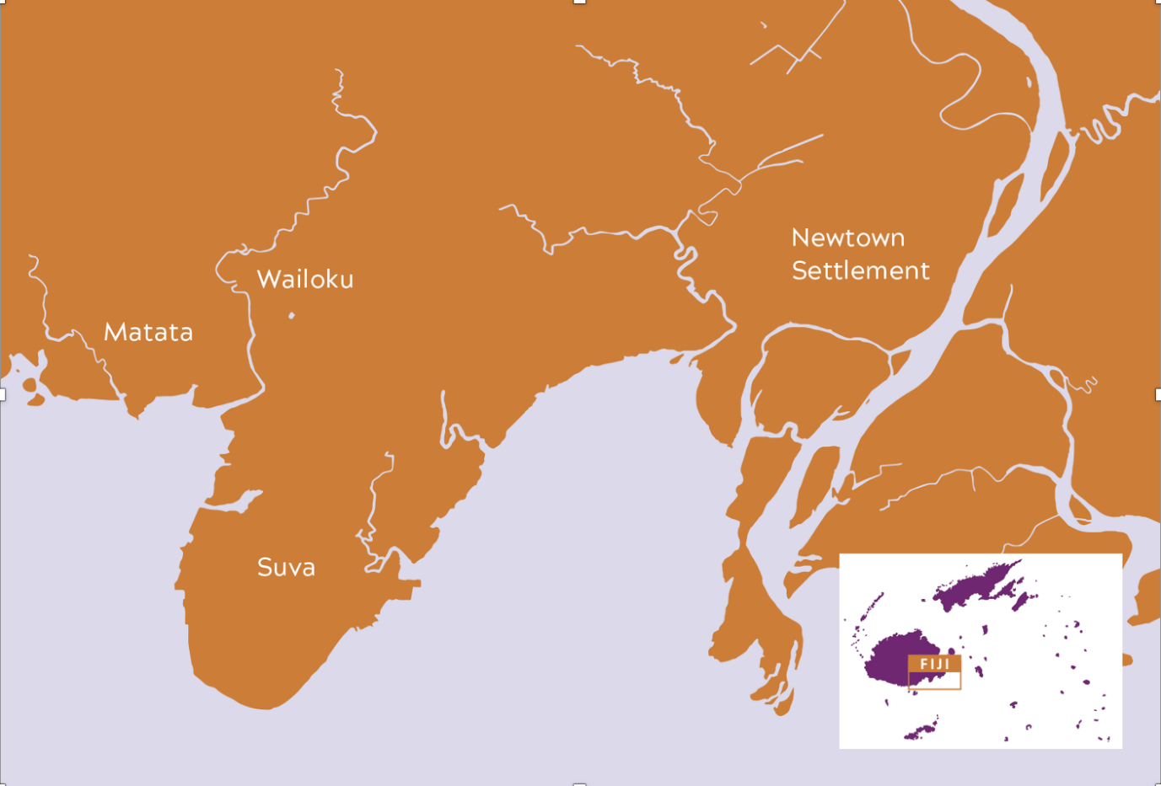

An adaptation of the internationally recognised SASA! Faith programme, PVAWFFS aims to empower communities to reject VAWG and prevent violence by reshaping power relations between men and women through Biblical teachings and faith networks. The project will achieve these aims through:

- Following a natural process of change - Change cannot be rushed and will not be sustained if people feel pressured. PVAWFFS takes the community through a step-by-step process, which includes: a) The faith community acknowledging VAWG as a problem; b) The faith community engaging in critically thinking, talking and learning about VAWG; c) The faith community considering alternatives, while receiving support and encouragement from each other; and d) The faith community creating ways to change together and to sustain that change.
- Engaging people at all levels - For gender-equal attitudes and behaviours and non-violent relationships to be sustained, everyone in the community needs to be talking about it and making changes. Everyone, from a religious leader to a person in a prayer group, influences the faith community’s use or experience of violence. When everyone is engaged, it makes it easier for everyone to change.
- Focusing on the root of the problem - At the root of VAWG are issues of power. Positive change only lasts if the root causes are meaningfully addressed. Like SASA! Faith, PVAWFFS looks at both the positive and negative uses of power in relationships and examines how VAWG occurs when men use their power negatively over women. It also illustrates how men and women can have stronger, happier and equal relationships when they learn to balance their power.
- Highlighting the benefits for all - Change occurs and is sustained when people understand its benefits. PVAWFFS highlights the positive effects of nonviolence and balanced power, including: trust and respect in faith communities, model relationships as described in the Bible, increased trust and connection with children, as well as improved academic performance in children, united families and communities, greater peace and security for everyone, and many more.

First developed and implemented by Raising Voices in Uganda, SASA! is an evidence-based approach to community mobilisation to prevent VAWG. It is now being used in 60 countries worldwide. SASA! uses a phased approach and multiple strategies to effect change, with activists and community members leading their own process of change. SASA! Faith, developed by Raising Voices and Trócaire, adapts SASA! for use in Christian and Muslim communities. https://raisingvoices.org/sasa/

The project has a dedicated project team of five people. Twenty-six Community Activists have been recruited to engage the community through their everyday lives and activities. In alignment with the SASA! methodology, Community Activists are individuals based within target communities who are advocates that spur widespread social mobilisation to end violence against women and girls.

Progress to date: The evidence
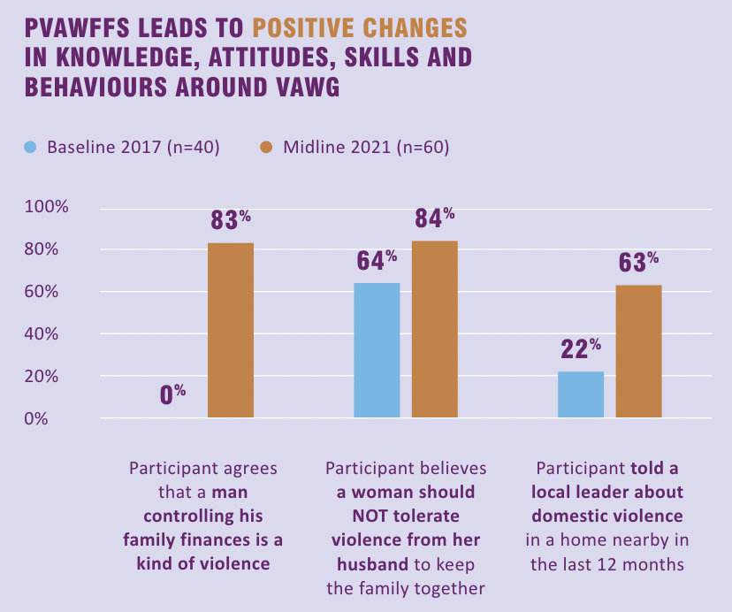

Challenges and successes of PVAWFFS

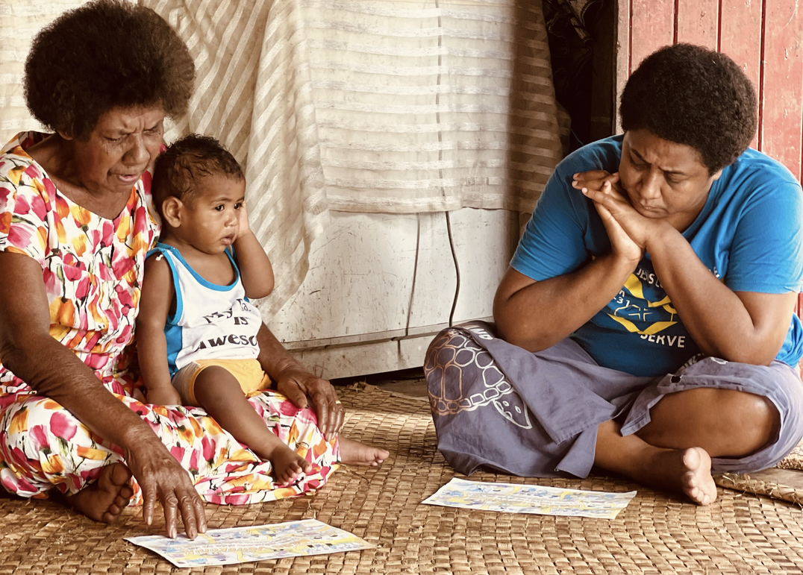

The PVAWFFS project has faced some challenges. In particular the the Community Activists’ (CA’s) roles are voluntary; if people secure other work, they are often unable to engage in their CA function. House of Sarah has continued to recruit, support and train new CA’s who operate as the heart of the SASA! Faith intervention. There were also challenges recruiting male CA’s due to beliefs that men do not have a role to play in addressing VAWG. However, after adopting a more targeted approach to recruitment, the team were able to recruit nine men to the project. Despite challenges, the project is achieving success. By using existing structures, such as the Men’s Ministry, outreach to men has been enhanced. Now, many men report positive changes in their lives and relationships. A 40-year-old man from Wailoku said, “If things were not followed, I’d beat my wife up. I was harsh on the kids. That’s how I disciplined my family. When the project came, I attended sessions given by community activists. I learned a lot there. I began to change the way I think. I needed to stop what I was doing. I became a member of the Men’s Group. Now, I share my story with other men in my community.” Key to the success of PVAWFFS is the passion supporters have for bringing positive changes from their own lives and sharing those with their community. Alisi and Tomu Dari, have used the positive changes in their relationship to illustrate to others that change is possible. Reverend Jone Tuiwaiwai also once “prioritised his friends, drinking and smoking” but made positive steps to change his life. He is now a pastor who preaches gender equality. He says: “There are things God gave us that we cannot change, but our social roles are not one of them. We can change them. People in my community saw me change my ways. I changed for a happy family, for a good community, and to be a role model.”

The COVID-19 pandemic has presented significant challenges globally for communities and organisations working to end VAWG. Many countries, including Fiji, have seen an increase in VAWG during the pandemic, and there have been increased barriers for support services, due to lengthy lockdowns. For the Sarah Carers and PVAWFFS, in-person support and activities were impossible due to the nation-wide lockdowns, so the Sarah Carers adapted to support women remotely using their mobile phones. PVAWFFS conducted virtual community activities, however limited connectivity, and access to technology among community members was a challenge. Community Activists also used the Christian Discussion Guides, a key activity from the project used to discuss sensitive issues and change attitudes from the project with their own extended families. Posters with key messages were also placed in community spaces.

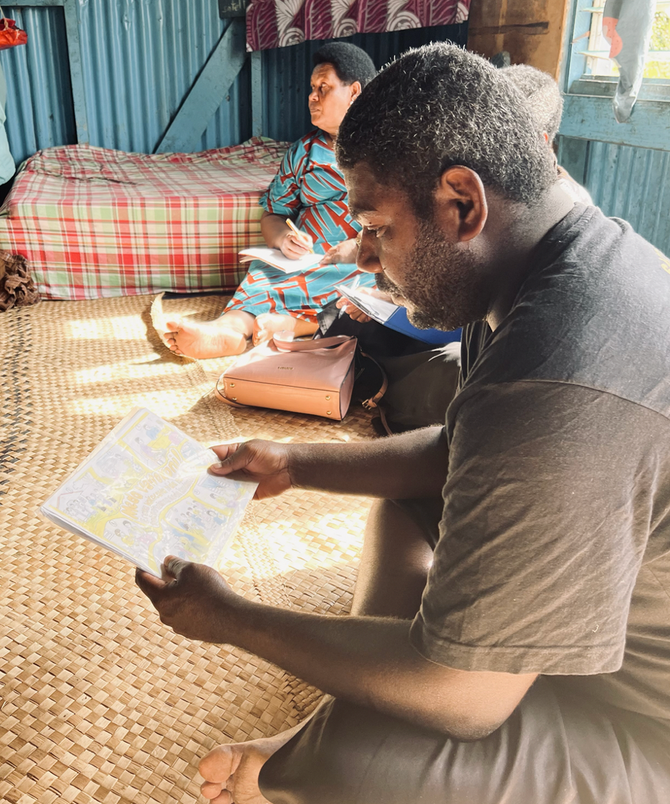

Principles and values for positive change in faith communities
Based on House of Sarah’s experience in Fiji and growing global evidence, there are key principles that are needed to best prevent VAWG in faith settings.

Center women and girls and adopt a survivor-centred approach
Centering women and girls and a survivor-centred approach ensures the lived experiences and safety needs of women and girls are met in all response and prevention activities.

Engage men and boys in preventing violence against women and girls
To truly address the issue of VAWG, men and boys must be meaningfully engaged across the community, government and, particularly in faith settings. In the Pacific, best practices for engaging men and boys in preventing VAWG must (1) be accountable to the women’s movement in the Pacific, (2) do no harm, (3) be grounded in a human-rights approach, (4) be evidence-based and evidence-building, (5) be inclusive and intersectional, (6) be gender transformative and (7) be informed by context.

Engage faith leaders as advocates
Faith leaders play important roles in communities and are a strategic entry point for VAWG prevention. Faith communities and churches are by nature patriarchal, and men make up the majority of leadership positions. As such, male faith leaders must be meaningfully engaged as advocates. However, faith leaders can hinder or enable gender equality and violence prevention. Leaders must first transform their own minds and hearts before they can challenge harmful social norms. They must be accountable and adhere to the belief that men and women are created equal in the eyes of God and principles of gender equality to become advocates for VAWG prevention. There are also many influential faith leaders who are women and increasing women’s leadership in faith institutions is key.
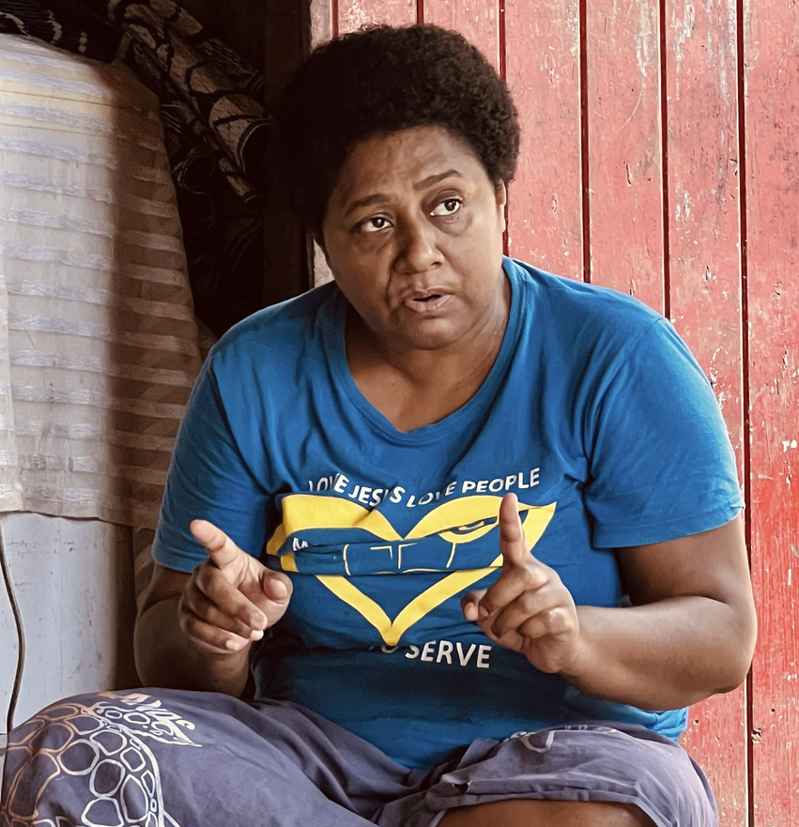

Actively challenge spiritual teachings and interpretations that condone VAWG
When addressing VAWG within the Christian faith context, it is important to actively challenge biblical teachings and interpretations that condone VAWG (and the teachers that promote them). Positively framing core spiritual values (such as peace and gender justice) and presenting alternative teachings that are equal and respectful, will positively influence social norms that are aligned with gender equality.

Adopt a multi-sectoral, collaborative approach, including an interfaith dialogue Collaboration can increase the effectiveness of interventions and partnerships at different levels are essential for effective, culturally appropriate and locally relevant service delivery and prevention. Collaborate with women’s organisations, health and legal services and other faith actors to strengthen the message of gender justice for the whole community.

Foster positive institutional change
It is vital that organisations working in faith settings develop and implement policies and practices that ensure places of worship and faith communities are safe for all and do not condone or cause violence.

Evidence-based and evidence-building
Utilise evidence-based primary prevention strategies and interventions that are adapted to context and fit-for-purpose. Rigorously monitor and evaluate programmes and commission research to build the evidence on what works to prevent VAWG in faith settings. In the Pacific, the evidence on prevalence of VAWG and its causes are well documented. It is equally critical to ensure we collect evidence that identifies the solutions to stopping violence before it starts.

A long-term commitment
Addressing VAWG, especially primary prevention, requires a long-term, sustainable commitment. Changes in knowledge, attitudes and behaviour and transformation of hearts and minds takes years and decades. It is critical that faith organisations and leaders meaningfully take up the issue of VAWG with a long-term perspective.

Looking ahead
Government and development partners need to:
- Increase investment, resourcing and financing for gender equality, violence prevention, social norms change and women and girls’ empowerment, including engaging in meaningful, values-driven partnership with faith-based organisations and women’s rights organisations. This investment must be long-term, multi-year and flexible.
- Engage a diverse range of faith actors for VAWG prevention and ensure their programmes and funding are accountable to the rights of women and girls, human rights, and gender equality principles.
- Develop opportunities for faith-based organisations to strengthen their capacity on VAWG prevention, foster learning with others and strengthen their relationships with women’s organisations.

Creating a future that is safe, equal, and free from violence
Faith settings are crucial for addressing violence against women and girls, and everyone - from the individual, the community, up to the highest faith leaders and governing bodies - has a role to play in creating safer, more equitable communities. Faith settings and leaders are especially vital sources of strength, inspiration, and support in communities, and should be at the heart of prevention programming. By working with faith leaders and communities, implementing these strategies and principles, and adopting a holistic and sustained approach, faith communities, governments, CSOs, development partners and communities together can effectively address and prevent violence and change the harmful gender norms that underpin VAWG in Fiji, the Pacific and beyond.
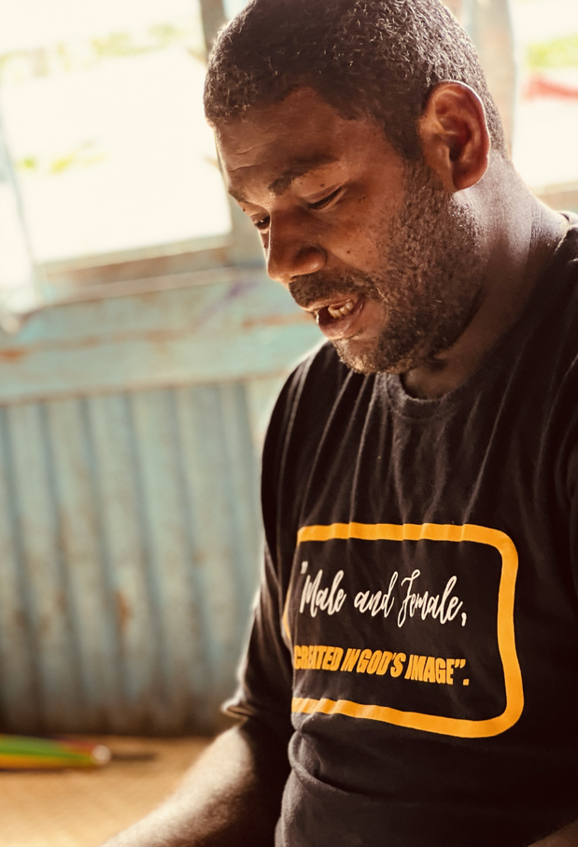

Acknowledgements
This paper was commissioned by UN Women Fiji Multi-Country Office (MCO)
and co-developed by Reverend Sereima Lomaloma and Alisi Qaiqaica of House of
Sarah; Sarah Homan and Loksee Leung of the Equality Institute (EQI); and Sonia
Rastogi, Shabina Khan and Shazia Usman of UN Women Fiji MCO. Publication
design by Catrin Harris and Scarlett Musu (EQI). The team gratefully acknowledges
the work, experience, and expertise of the team at House of Sarah. The PVAWFFS
project receives technical support from UN Women and Raising Voices. It is
implemented with support from the Pacific Partnership to End Violence Against
Women and Girls (Pacific Partnership). In addition to being supported by the
Pacific Partnership primarily through the European Union, the Governments of
Australia and New Zealand, and UN Women, House of Sarah’s PVAWFFS project
was also supported by the Women’s Fund Fiji (also through the Government of
Australia) from 2018 to 2020.
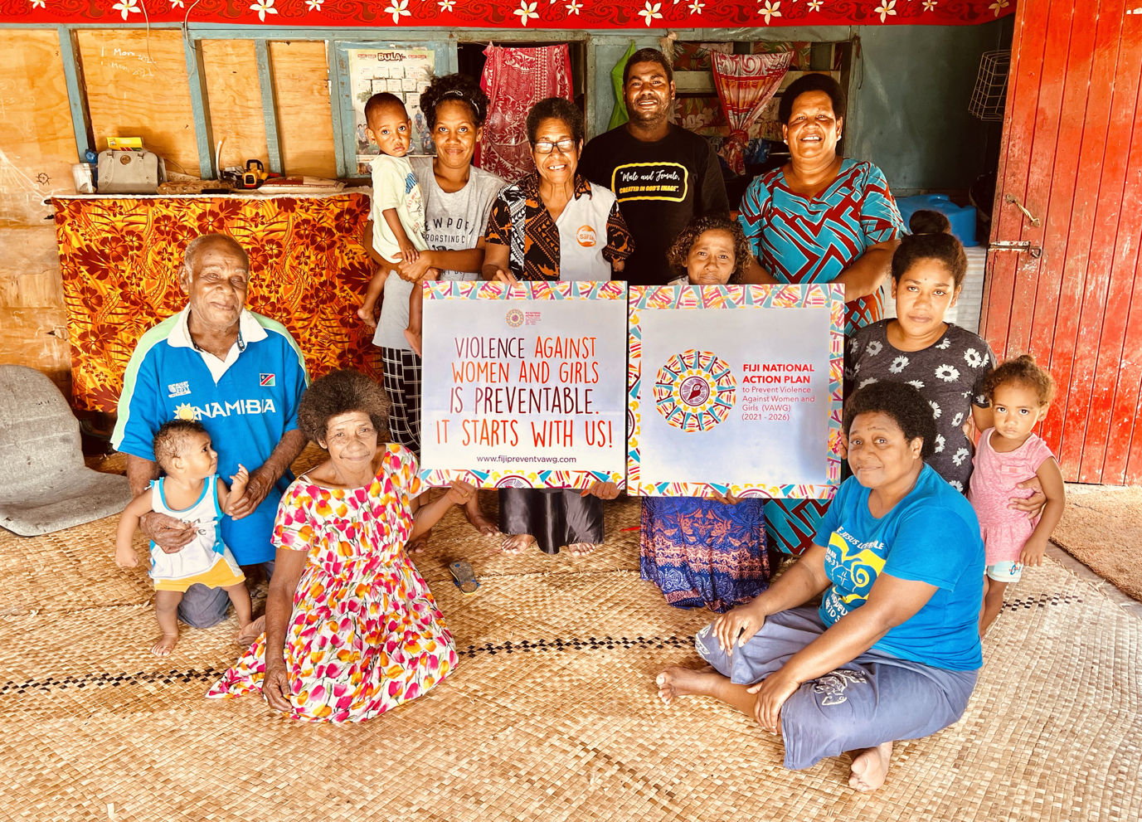

End notes

García-Moreno, C., et al. (2015). “Addressing violence against women: A call to action.” The Lancet, 385(9978): 1685-1695.
RESPECT women: Preventing violence against women. Geneva: World Health Organization; 2019
K.M. Devries et al. (2013). ‘Global health. The global prevalence of intimate partner violence against women’. Science 340(6140), pp. 1527–1528.
Fiji Women’s Crisis Centre (2013). Somebody’s Life, Everybody’s Business! National Research on Women’s Health and Life Experiences in Fiji (2010/2011)
The Prevention Collaborative (2020) “Roadmap of VAW Prevention Interventions”. Prevention Basics Brief 3.
See the RESPECT Framework (2021) for more on evidence-based prevention strategies for preventing VAWG.
Vaughan, C., Sullivan, C., Chen, J., Vaid Sandhu, M. (2020). What works to address violence against women and family violence within faith settings: An evidence guide, Parkville: University of Melbourne.
Stawski, H., O’Sullivan, V., Dartnall, E., el Feki, S., Arango, D., Karam, A. (2016). Faith communities are key actors in empowering and protecting girls and addressing gender-based violence, Washington D.C.: JLI F&LC.
Tomkins, A., et. al. (2015). Controversies in faith and health care. The Lancet.
Duff, J. F., & Buckingham, W. W. (2015). Strengthening of partnerships between the public sector and faith-based groups. The Lancet.
The Prevention Collaborative (2020) “Roadmap of VAW Prevention Interventions”. Prevention Basics Brief 3.
Dauveivukei in the I-Taukei language is ‘expert helper’.
Fiji Ministry of Women, Children and Poverty Alleviation (2018). “Fiji National Service Delivery Protocol for Responding to Cases of Gender Based Violence.”
For more on One Voice, see the following campaign videos: ‘My Faith Says No' TV Campaign One, ‘My Faith Says No' TV Campaign Two, ‘My Faith Says No' TV Campaign Three, ‘My Faith Says No' TV Campaign Four.
Raising Voices (2006) SASA! Faith A Guide to Faith Communities to Prevent Violence Against Women and HIV.
Chanel, S. (Feb 2021), "'Crisis within a crisis: Violence against women surges in Fiji", Al Jazeera https://www.aljazeera.com/news/2021/2/24/crisis-within-a-crisis-violence-against-women-surges-in-fiji
Fiji Women’s Crisis Centre, UN Women (2020) The Warwick Principles: Best Practices for Engaging Men and Boys in Preventing Violence Against Women and Girls in the Pacific: Navigating the Pacific Region towards Respectful and Equal Societies, Suva, Fiji
Stawski, H., O’Sullivan, V., Dartnall, E., el Feki, S., Arango, D., Karam, A. (2016). Faith communities are key actors in empowering and protecting girls and addressing gender-based violence, Washington D.C.: JLI F&LC.

